**Vishwakarma Institute of Technology, Pune**

**Department of Computer Engineering**

**Semester II (2024-25)**

**Class: SY B Course Coordinator: Mrs A.B.Burujwale Course: Operating System**

**List of Tutorials**

1. Know your Operating System.

2. Elaborate about the types of Operating System

3. Explain different architectures of Operating system

4. Write the solutions for following synchronization problems:

i. Producer Consumer

ii. Reader Writer

iii. Dining Philosopher

5. CPU Scheduling

i. Schedule the following processes using First come first serve scheduling and computer the waiting time:

| **Process ID** | **Burst**  **Time** |
| --- | --- |
| P1 | 24 |
| P2 | 3 |
| P3 | 3 |

ii. Schedule the following processes using Shortest Job First (SJF) scheduling:

| **Process ID** | **Arrival Time** | **Burst Time** |
| --- | --- | --- |
| A | 0 | 3 |
| B | 2 | 6 |
| C | 4 | 4 |
| D | 6 | 5 |
| E | 8 | 2 |

iii. Scheduling the following processes using Round Robin scheduling where Time Quantum = 100ms

| **Process**  **Name** | **Arrival Time**  **(in ms)** | **Execution Time (in ms)** |
| --- | --- | --- |
| P0 | 0 | 250 |
| P1 | 50 | 170 |
| P2 | 130 | 75 |
| P3 | 190 | 100 |
| P4 | 210 | 130 |
| P5 | 350 | 50 |

6. **Solve the following problems of the deadlock concept**.

I. Find the sequence in which the processes get handled by CPU to avoid deadlock using banker's algorithm.:-

Number of processes: 5 (P0 to P4)

Resources:

Resource A: Number of instances: 10

Resource B: Number of instances: 5

Resource C: Number of instances: 7

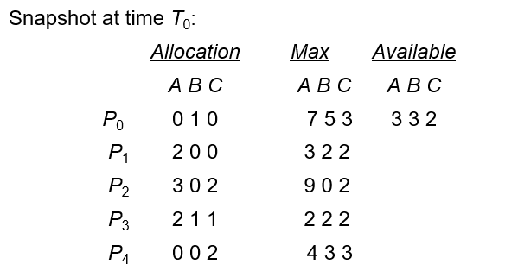

Ii. Find whether the system is in safe state or the deadlock is occurred considering following scenario:

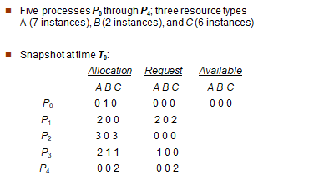

7. **Memory Management**

1. Following is the list of available blocks in the main memory and the process size for each process (P0 to P3).

blockSize[] = {100, 500, 200, 300, 600}

processSize[] = {212, 417, 112, 426}

Find which memory block is allocated to which process using following placement strategies:

1. First Fit
2. Next fit
3. Worst fit
4. Best fit

II. Consider the page reference string as 7,1,0,2,0,3,0,4,2, 3, 0, 3, 2, 1, 2, 0, 1, 7, 0, 1 with 3-page frames. Find the total number of page faults using following page replacement algorithms:

1. First In First Out
2. Optimal
3. Least recently used
4. Second Chance (Clock)

8**. Disk Scheduling**

Consider the order of request for cylinder access of the disk is - (98, 183, 37, 122, 14, 124, 65, 67) and current position of Read/Write head is: 53. Find the total head movements to access the data on the cylinder using following algorithms:

1. First Come First Serve (FCFS)
2. Shortest Seek Time First (SSTF)
3. SCAN
4. C-SCAN

9. Write short note on Input /Output organization

10. Elaborate about Record blocking